**TRƯỜNG THCS PHAN CÔNG HỚN**

**TỔ TIẾNG ANH - TIẾNG ANH 8**

**TUẦN 25 (TỪ 03/03 ĐẾN 08/03)**

**PERIOD 73,74 REVIEW UNIT 6**

***I. Listen to the record player three times, then choose the best answer (A, B, C or D). (1pt)***

***(Từ câu 1 đến câu 4, thí sinh chỉ viết mẫu tự (A, B, C hoặc D) đại diện cho câu trả lời đúng vào Phần ANSWERS)*** *(SB-Review U6-CD2-43)*

**1.**

**2.**

**3.**

**4.**

**ANSWERS**

1. Where does David think people will live in 200 years?

A. on another planet B. on space stations C. underground D. on Earth

2. What is impossible for people to do on Mars?

A. Hiking B. Swimming C. Breathing D. Walking

3. What did Alex see at the market?

A. a space station B. an explosion C. an alien D. a flying saucer

4. Who thinks Earth is the only perfect place to live in the future?

A. Lisa’s teacher B. Ben C. David D. Alice

***II. Choose the word or phrase (A, B, C or D) that best fits the space or best answers the question given in each sentence. (2.5 pts)***

***(Từ câu 5 đến câu 14, thí sinh chỉ viết mẫu tự (A, B, C hoặc D) đại diện cho câu trả lời đúng vào Phần ANSWERS)***

**5.**

**6.**

**7.**

**8.**

**9.**

**10.**

**11.**

**12.**

**13.**

**14.**

**ANSWERS**

**12.**

**13.**

**14.**

5. Which word has the underlined part pronounced differently from that of the others?

A. finish**ed** B. stopp**ed** C. agre**ed** D. laugh**ed**

6. Which word has the underlined part pronounced differently from that of the others?

A. l**ea**f B. h**ea**lth C. h**ea**d D. d**ea**f

7. Which word has a different stress pattern from that of the others?

A. visitor B. popular C. alien D. important

8. Which word has a different stress pattern from that of the others?

A. planet B. station C. affect D. people

9. Some people live and work in space. The rest live on _____.

A. Earth B. Mars C. Mercury D. Venus

10. _____ is what we use to measure if something is cold or hot.

A. space station B. temperature C. ruler D. weather

11. I _____ in bed when I heard a loud noise outside.

A. lies B. am lying C. lied D. was lying

12. Water is made up of the elements hydrogen and _____.

A. sulphate B. oxygen C. aluminium D. calcium

13. Researchers think that Vietnam’s population _____ to grow steadily in the future, but at a slower rate.

A. will continue B. continued C. are continuing D. has continued

14. Vietnam’s climate is similar _____ that of other Southeast Asian countries like Thailand and Cambodia.

A. in B. from C. to D. on

***III. Look at the signs. Choose the best answer (A, B, C or D) for questions 15 and 16. (0.5pt)***

***(Từ câu 15 đến câu 16, thí sinh chỉ viết mẫu tự (A, B, C hoặc D) đại diện cho câu trả lời đúng vào Phần ANSWERS)***

15.What does the sign mean?

**16.**

**15.**

**ANSWERS**

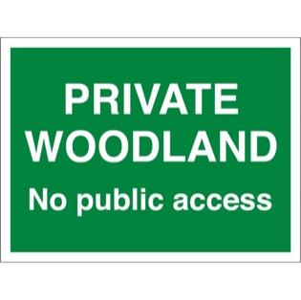

A. The woodland area is open to the general public.

B. The woodland owner can force you to get out of his land.

C. Public access is not restricted in this area.

D. Anyone has the right to visit this wood.

16. What does the sign say?

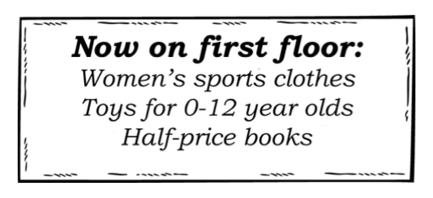A. You can find all types of women’s clothes on the first floor.

B. There are books on sale on the second floor.

C. This supermarket doesn’t have any floors.

D. Children under 13 may find their favourite toys on this floor.

***IV.* *Choose the word (A, B, C or D) that best fits the space in the following passage. (1.5 pts)***

***(Từ câu 17 đến câu 22, thí sinh chỉ viết mẫu tự (A, B, C hoặc D) đại diện cho câu trả lời đúng vào Phần ANSWERS)***

**Strange Experiences**

These days, more and more people are reporting (17)_____ experiences with aliens and UFOs. I think it's really exciting. Last month, a woman was doing the laundry when she (18)_____ a huge object in the sky above her house. She is sure it was a flying saucer. Yesterday, a teenage boy was studying at the library when he saw a tall man (19)_____ green skin and blue hair. He was laughing. The boy was very (20)_____.

**17.**

**18.**

**19.**

**20.**

**21.**

**22.**

**ANSWERS**

If aliens are real, why do they come to our planet? Some people say that (21)_____ like the temperature or gravity here, but I don't agree. I think they want to meet people. I think that in the future, more and more aliens (22)_____ to our planet. I hope that we will be able to ride in their flying saucers, too!

17. A. ordinary B. usual C. normal D. strange

18. A. sees B. saw C. has seen D. is seeing

19. A. with B. have C. has D. had

20. A. scare B. scary C. scared D. scarily

21. A. he B. they C. she D. we

22. A. are coming B. came C. comes D. will come

***V*. *Read the following passage. Decide if the statements from 23 to 26 are True or False and choose the correct answer (A, B, C or D) for the questions 27 and 28*. *(1.5 pts)***

***(Từ câu 23 đến câu 26, thí sinh viết đầy đủ từ True hoặc False vào ô trả lời. Mọi cách viết khác không được chấm điểm. Đối với câu 27 và 28, thí sinh chỉ viết mẫu tự (A, B, C hoặc D) đại diện cho câu trả lời đúng vào Phần ANSWERS)***

**Life in the Universe: Are We Alone?**

Have you ever looked up at the stars and wondered, "Is there life out there?" This is a big question, and scientists are searching for the answer.

Our universe is extremely big, with billions of galaxies, and each galaxy has billions of stars. Many of these stars have planets orbiting them, just like Earth goes around the sun. Some of these planets might be the right distance from their star to have water, which is important for life as we know it.

So, are we alone? We don't know yet, but the search for life beyond Earth is exciting! Scientists are looking for signs of life on other planets by studying their atmospheres and searching for signals from **intelligent beings**.

**23.**

**24.**

**25.**

**26.**

**27.**

**28.**

**ANSWERS**

The possibility of life in the universe is a fascinating mystery. Whether we find simple organisms or advanced civilizations, discovering life beyond Earth would change how we see our place in the universe. It's a big universe out there, and who knows what we might find!

23. Scientists have found the answer to the given question.

24. We cannot count the number of galaxies and stars because our universe is enormous.

25. The search for life beyond Earth is still in progress.

26**.** It is clear that there are other forms of life in the universe besides our planet.

27. The word “**intelligent beings**” can be referred to:

A. aliens B. smart humans C. moving objects D. exotic animals

28. According to the passage, _____ is one of the important conditions for life.

A. suitable temperature B. gravity C. having water D. oxygen

***VI. Use the correct form of the word given in each sentence. ( 1.5 pts)***

***(Từ câu 29 đến câu 34, thí sinh phải viết từ cần điền vào Phần ANSWERS bên dưới câu hỏi)***

29. The aliens from another planet were _____ to the humans, but they wanted to be friends. (STRANGE)

30. A small, green creature _____ behind a rock and the space explorers couldn't find it. (APPEAR)

31. The little alien was _____ when it saw the big, scary robot. (TERRIFY)

32**.** The spaceship landed in a _____ clearing in the forest on the new planet. (CIRCLE)

33. The _____ of the story tells us about the amazing adventures on a planet far away. (NARRATIVE)

34. The alien lifeforms have a unique set of _____, such as big eyes and long arms. (CHARACTER)

**29.**______________ **30.**______________ **31.**______________

**ANSWERS**

**32.**______________  **33.**______________  **34.**______________

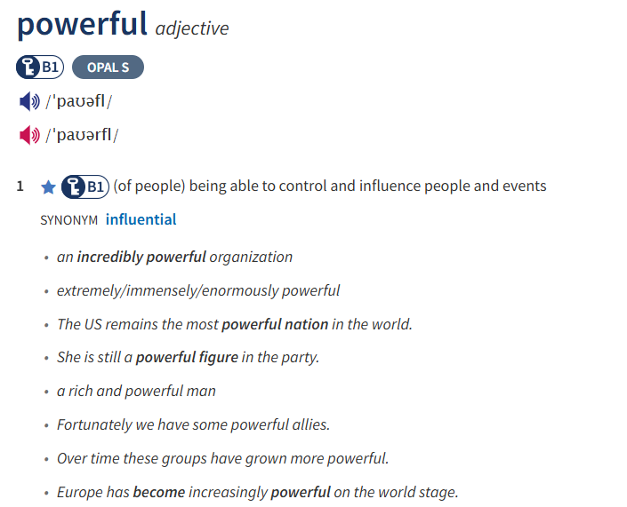

***35.The United States is considered a _____________ with significant influence in global politics.***

***36.Her voice is _______________________, capable of moving anyone who listens.***

***VIII. Rewrite each of the following sentences in another way so that it means almost the same as the* *sentence printed before it. (1.0pt)***

***(Từ câu 37 đến câu 40, thí sinh hoàn thành phần trả lời bên dưới mỗi câu)***

37. The atmosphere on Earth is not as thin as that on Mars.

🡪 The atmosphere on Mars is

38. The layout of this apartment is different from our old one.

🡪 The layout of this apartment is not

39. The farmers were working in the field when they saw a flying saucer across their farmland.

🡪 While the farmers

40. How much is a trip to space?

🡪How much does

**THE END OF THE TEST**

**PERIOD 75:**

**UNIT 7: TEENS - LESSON 1.1**

1. **VOCABULARY**
2. game designer /ˈɡeɪm dɪˈzaɪnə(r)/ (n) người thiết kế trò chơi

design /dɪˈzaɪn/ (v) lên thiết kế cái gì

(n) sự thiết kế

2. dentist /ˈdentɪst/ (n) nha sĩ

3. director /daɪˈrektə(r)/ (n) đạo diễn/ giám đốc

direct /daɪˈrekt/ hoặc /dɪˈrekt/ (v) hướng dẫn, chỉ đạo

direct /daɪˈrekt/ hoặc /dɪˈrekt/ (adj) trực tiếp ≠ indirect (adj) gián tiếp

direct /daɪˈrekt/ hoặc /dɪˈrekt/ (adv)

direction /daɪˈrek.ʃən/ (n) phướng hướng

4. dream /driːm/ (n) ước mơ

dreamy/ˈdriː.mi/(adj) không tập trung, mơ màng / mơ mộng nên thơ

5. engineer /ˌendʒɪˈnɪə(r)/ (n) kỹ sư

engineering/ˌen.dʒɪˈnɪə.rɪŋ/ (n) ngành kĩ thuật

6. flight attendant /ˈflaɪt ətendənt/ (n) tiếp viên hàng không

fly- flew -flown (v) bay

flight /flaɪt/ (n) chuyến bay

attend /əˈtend/ (v) tham gia, tham dự

attendant /əˈten.dənt/ (n) người luôn có mặt để phục vụ, tiếp viên

attendance /əˈten.dəns/ (n) việc tham gia

Attendance check: Điểm danh

7. journalist /ˈdʒɜːnəlɪst/ (n) nhà báo

journal /ˈdʒɜː.nəl/ (n) tờ báo, tập san

Journalism /ˈdʒɜː.nə.lɪ.zəm/ (n) ngành báo chí

8. musician /mjuˈzɪʃn/ (n) nhạc sĩ

Music /ˈmjuː.zɪk/ (n) âm nhạc

classical/pop/dance/rock music

musical /ˈmjuː.zɪ.kəl/ (a) thuộc về âm nhạc

musical instruments: nhạc cụ

9. veterinarian /ˌvetərɪˈneəriən/ (n) bác sĩ thú y ( hay viết tắt là vet /vet/)

10. vlogger /ˈvlɒɡə(r)/ (n) người làm vlog (vlog = video + blog)

**II. PRACTICE**

**EXERCISE 1 Complete the sentences using the given words.**

***game designers journalist musicians veterinarian***

***dentist director dream engineer flight attendants vlogger***

1. He is a very famous film_________in Vietnam.

2. Four _________for American Airlines were awarded a lot of money last week

3. You should visit your _________ to take care of your teeth.

4. _________often work as part of a team and might focus on one aspect of game creation.

5. He is a(n)_________at a [large](https://dictionary.cambridge.org/vi/dictionary/english/large) [electronics](https://dictionary.cambridge.org/vi/dictionary/english/electronics) [company](https://dictionary.cambridge.org/vi/dictionary/english/company).

6. Consult your _________if your cat is still not eating.

7. She's working for a French newspaper as a(n) _________.

8. Many pop and rock_________sing in English rather than their mother tongue.

9. His dead mother appeared to him in a _________.

10. My sister is a(n)______________. She makes videos for viewers on the internet.

**EXERCISE 2 Mark the letter A, B, C, or D to indicate the correct answer to each of the following questions.**

1. I want to go to university because it’s my ____ to be a doctor.

A. dream B. sight C. view D. hobby

2. This vlogger is famous_____ many videos about the countryside in Vietnam.

A. with B. for C. in D. from

3. My dream ____ is to become a vlogger.

A. house B. package C. job D. packet

4. I really want to be a flight_____ in my future.

A. trip B. attendant C. guide D. attendance

5. I want to be a ______________ like my uncle. He helps people have beautiful smiles.

A. florist B. veterinarian C. dentist D. journalist

6.  My brother is a(n) ­­______. He takes care of animals all day.

A. designer B. veterinarian C. director D. engineer

7. His dream is to open a _____.

A. café B. coffee shop C. cafeteria D. All are correct

8. I write articles for a local newspaper. I am a (n)_______________.

A. designer B. veterinarian C. journalist D. engineer

9. I make online videos about my travel experience. I am a(n)_____________

A. vlogger B. veterinarian C. director D. engineer

10. I work in a factory and build machines. I am a(n)________.

A. designer B. veterinarian C. director D. engineer

**EXERCISE 3: Word forms**

1. What does a ***__________________*** do? (**JOURNAL)**

2. My cousin is one of the country's top fashion ***_______________***. (**DESIGN)**

3. The ***__________*** time from Nha Trang to Ho Chi Minh city is less than one hour. ( **FLY)**

4. There was an ***_______________*** of 42 at the meeting. ( **ATTEND)**

5. She [keeps](https://dictionary.cambridge.org/vi/dictionary/english/keeps) [looking](https://dictionary.cambridge.org/vi/dictionary/english/looking) in my ***______________***. (**DIRECT)**

6. I want to go to university because it’s my ***_____________*** to become a doctor. ( **DREAMY)**